Daniel Cody

Professor Labouseur

Database Systems

3 November 2014

Lab 8:

1.

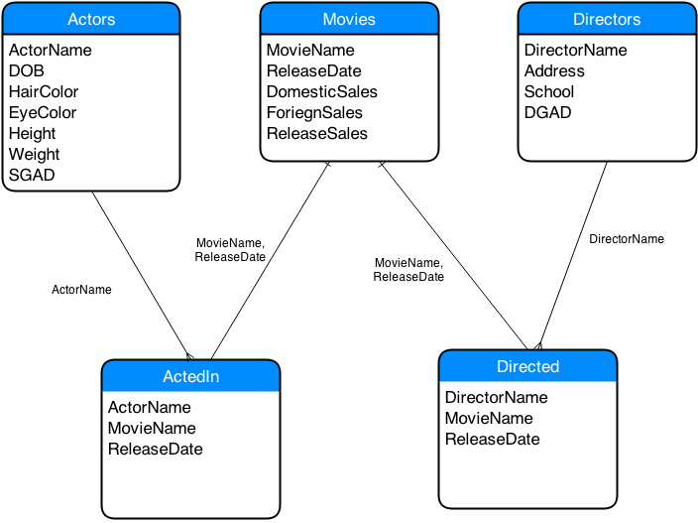

Primary Keys:

Actors: ActorName, since the Screen Guild requires that no two names are the same.

Movies: MovieName & ReleaseDate, a composite key of both insuring that movies that have been redone, ex: King Kong, are uniquely identified

Directors: DirectorName, the Directors Guild insures that no two names are the same

ActedIn: ActorName, MovieName, ReleaseDate, a composite key that identifies the actor and the movie that he acted in

Directed: DirectorName, MovieName, ReleaseDate, a composite key that identifies the director and the movie that he acted in

2.

CREATE TABLE Actors (

ActorName text NOT NULL,

DOB date NOT NULL,

HairColor text NOT NULL,

EyeColor text NOT NULL,

Height text NOT NULL,

Weight text NOT NULL,

SGAD date NOT NULL,

PRIMARY KEY(ActorName)

) ;

CREATE TABLE Directors (

DirectorName text NOT NULL,

Address text NOT NULL,

School text NOT NULL,

DGAD date NOT NULL,

PRIMARY KEY(DirectorName)

) ;

CREATE TABLE Movies (

MovieName text NOT NULL,

ReleaseDate date NOT NULL,

DomesticSales integer NOT NULL,

ForeignSales integer NOT NULL,

ReleaseSales integer NOT NULL,

PRIMARY KEY(MovieName, ReleaseDate)

) ;

CREATE TABLE ActedIn (

ActorName text NOT NULL,

MovieName text NOT NULL,

ReleaseDate date NOT NULL,

PRIMARY KEY(ActorName, MovieName, ReleaseDate)

) ;

CREATE TABLE Directed (

DirectorName text NOT NULL,

MovieName text NOT NULL,

ReleaseDate date NOT NULL,

PRIMARY KEY(DirectorName, MovieName, ReleaseDate)

) ;

3.

--Actors Table--

INSERT INTO actors

(ActorName, DOB, HairColor, EyeColor, Height, Weight, SGAD)

VALUES (‘Sean Connery’, ‘8/25/30’, ‘White’ , ‘Brown’, 74, 200, ‘6/14/72’);

INSERT INTO actors

(ActorName, DOB, HairColor, EyeColor, Height, Weight, SGAD)

VALUES ('Ursula Andress', '3/9/36', 'Blonde', 'Brown', 65, 120, '3/12/75');

INSERT INTO actors

(ActorName, DOB, HairColor, EyeColor, Height, Weight, SGAD)

VALUES (‘Harrison Ford’, '7/13/342', ‘Grey’, 'Brown', 73, 200, '4/11/71');

--Directors Table—

INSERT INTO directors

(DirectorName, Address, School, DGAD)

VALUES ('Terrance Young', '100 Brook Hill Drive', 'Cambridge', '5/30/71');

INSERT INTO directors

(DirectorName, Address, School, DGAD)

VALUES ('Irvin Kershner’, ’1801 N Broad Street’, 'Temple University’, '7/5/73');

--Movies Table--

INSERT INTO movies

(MovieName, ReleaseDate, DomesticSales, ForeignSales, ReleaseSales)

VALUES ('Dr No', '5/8/62', 16067035, 43500000, 23400000);

INSERT INTO movies

(MovieName, ReleaseDate, DomesticSales, ForeignSales, ReleaseSales)

VALUES (‘Never Say Never Again’, '10/7/83', 55500000, 1045000, 41200000);

INSERT INTO movies

(MovieName, ReleaseDate, DomesticSales, ForeignSales, ReleaseSales)

VALUES (‘Star Wars: Episode V, '6/20/80', 75000000, 3045000, 82300000);

--ActedIn Table--

INSERT INTO actedin

(ActorName, MovieName, ReleaseDate)

VALUES (‘Sean Connery’, ‘Dr No’, ‘5/8/62’);

INSERT INTO actedin

(ActorName, MovieName, ReleaseDate)

VALUES (‘Ursula Andress’, ‘Dr No’, ‘5/8/62’);

INSERT INTO actedin

(ActorName, MovieName, ReleaseDate)

VALUES (‘Sean Connery’, ‘Never Say Never Again’, ‘10/7/83’);

INSERT INTO actedin

(ActorName, MovieName, ReleaseDate)

VALUES (‘Harrison Ford’, ‘Star Wars: Episode V’, ‘6/20/80’);

--Directed Table--

INSERT INTO directed

(DirectorName, MovieName, ReleaseDate)

VALUES ('Terrance Young', 'Dr No', '5/8/62');

INSERT INTO directed

(DirectorName, MovieName, ReleaseDate)

VALUES ('Irvin Kershner', 'Never Say Never Again', '10/7/83');

INSERT INTO directed

(DirectorName, MovieName, ReleaseDate)

VALUES ('Irvin Kershner', 'Star Wars: Episode V', '6/20/80');

4.

--Actors Table--

ActorName -> Birthday, HairColor, EyeColor, Height, Weight, GAD

--Directors Table--

DirectorName -> Address, School, DGAD

--Movies Table--

--ActedIn Table--

--Directed Table--

5.

SELECT \* FROM

directors WHERE directorname IN

(SELECT directorname FROM directed d

WHERE d.movieName, d.releaseDate IN

(SELECT m.movieName, m.releaseDate FROM movies m

WHERE m.movieName IN

(SELECT a.movieName FROM actedin a

WHERE a.actorName = 'Sean Connery')));